**Network and Information Security Management Assessment for e-commerce website**

**Introduction**

This report investigates an e-commerce website used to provide payment services and advice for commercial website operators. Attacks to this type of websites utilise vulnerabilities specific to the e-commerce websites, such as shopping cart, or vulnerabilities common to any web application, such as SQL injection or cross-site scripting. One of the most critical guides that we will consider through this process is the OWASP (OWASP, 2020), which constitutes an essential and globally approved framework to use as a starting point. The methodology, scanning tools, and limitations will be analysed through the first part of the reconnaissance and evidence evaluation. At a later stage, a new report will be produced explaining the vulnerabilities aligned with the industry’s standards. The report will also include suggestions to mitigate the potential risks and non-conformities.

**Methodology**

In his article “OSI: The Internet That Wasn’t” (2013), Russell shares a brief history and the surrounding thought process that helped the industry conclude TCP/IP stack as the de facto standard. Inspired by the idea of layered modularity, we try to bolster the test procedures and develop a structured approach while examining the website in the bottom-up fashion through the TCP/IP stack (*Figure 1*). We use manual testing to understand the modus operandi rather than blindly relying on automated scripts to understand the testing process better.

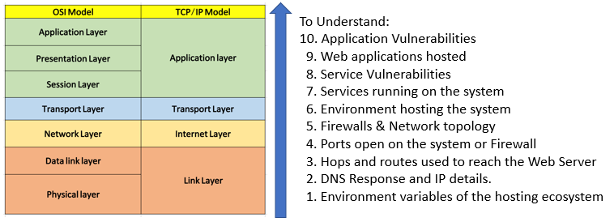

*Figure 1: Bottom-Up approach*

First, we try to recognise the neighbouring elements in the architecture enveloping the target web server. We found details like the environment hosting the web server, time to live (TTL), hops needed to reach the web server, and the DNS response. Examining the domain name helped us confirm that the web server is hosted on Amazon Web Services. The DNS resolution yielded only one record for an IPv4 address (Figure 2). The IP is registered under American Registry for Internet Numbers (ARIN) in the name of Amazon Technologies .Inc (Figure 3). Traceroute relies on ICMP protocol, so we checked if the server responds to ICMP to find the hops’ number until the web server IP. We witnessed that some intermediary hops timed out (with request timed out) possibly due to the firewall configurations on the internet service providers (ISP). Many ISPs disable the ICMP packets internally to avoid flooding and enforce what internet service providers refer to as topology hiding (Figure 5).

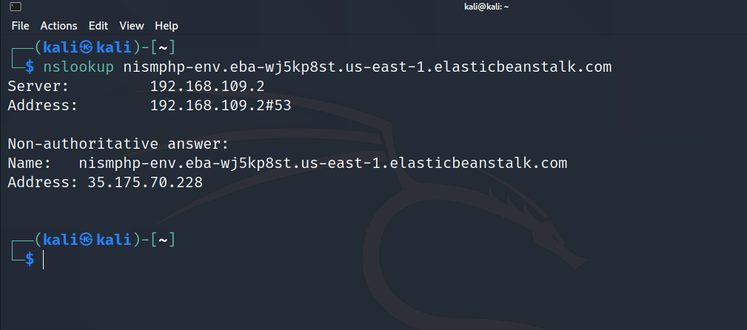

*Figure 2: DNS resolution using NSLOOKUP*

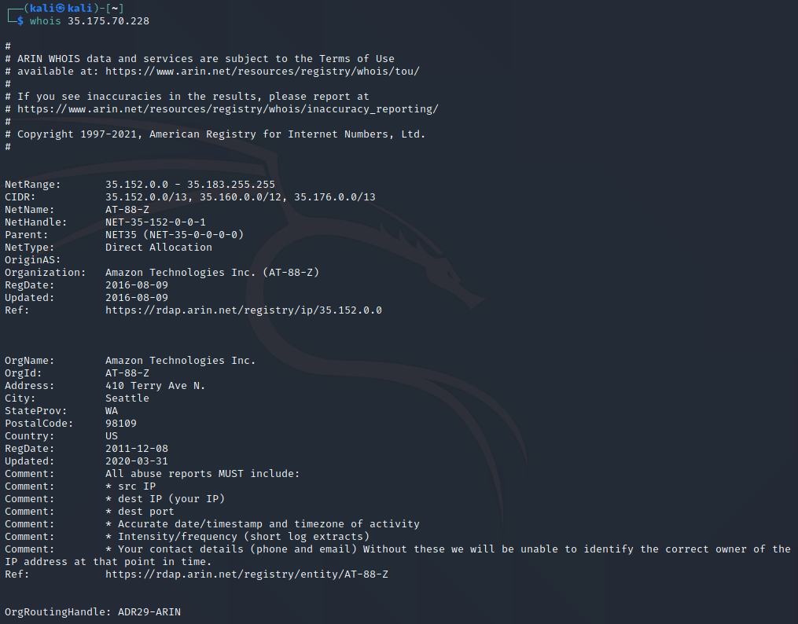

*Figure 3: IP ownership and registration using WHOIS*

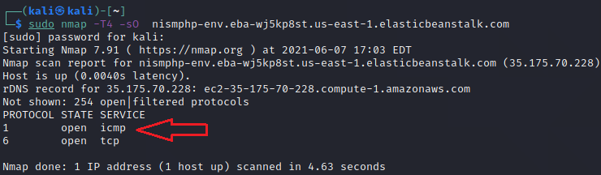

*Figure 4: Checking Server for ICMP protocol*

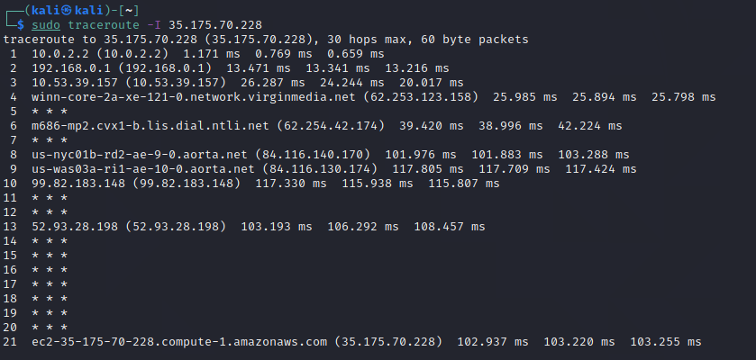

*Figure 5: Reckoning the total path to the final destination through the hops*

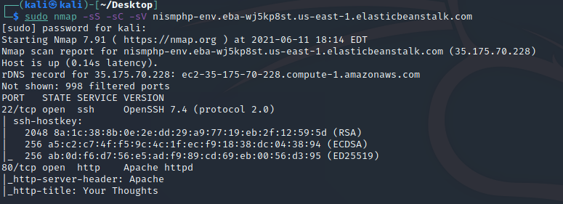

*Figure 6: Using nmap to scan for open TCP ports and the services running on them*

We use NMAP to scan for the Transmission Control Protocol (TCP) ports, revealing that two services are open and listening services on port 22 and port 80. Since TCP protocol works on a 3-way handshake; we try to see beyond the outcome from the scan above and initiate handshake by sending TCP SYN for all ports (1 - 65535) towards the destination server using nping. An intriguing find worth mentioning is that port 443 was also open on the firewall, and the TCP SYN were rejected with an RST by the destination server (Figure 7 & 8).

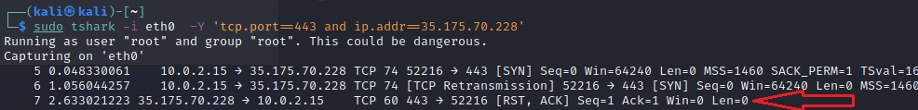

*Figure 7: RST received from port 443*

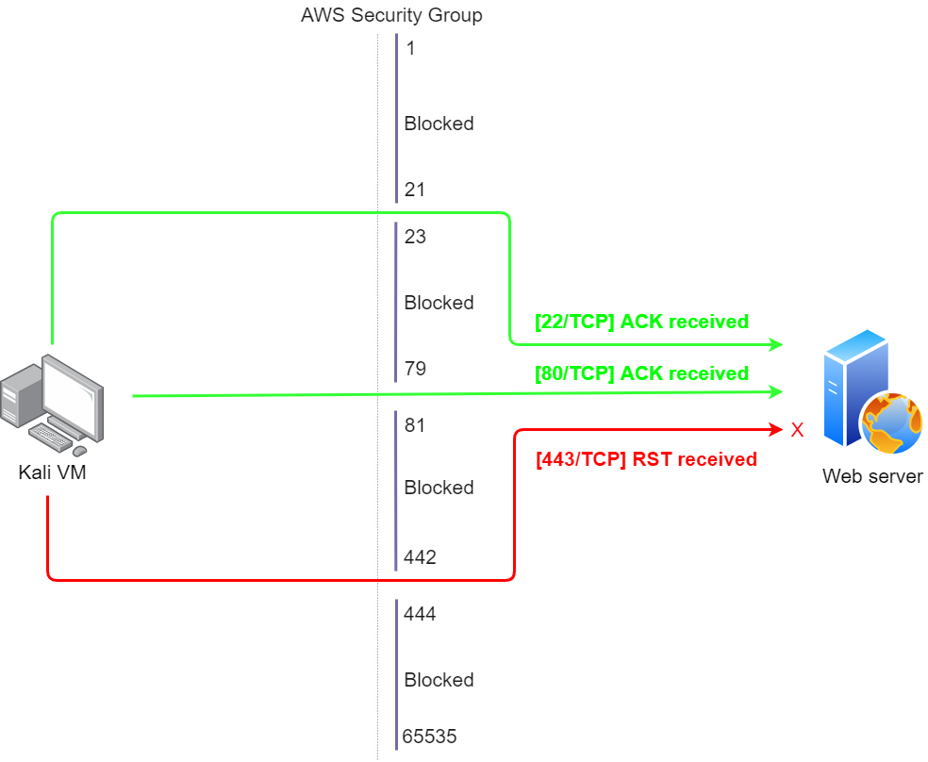

*Figure 8: Open TCP Ports on the firewall*

The internet browser helped us confirm that the web server was running on port 80, making it insecure. This fact makes the HTTP requests and responses human-readable when eavesdropped using a packet capturing tool like tshark without any need to decrypt it (*Figure 9*). We use HTTP add to publish a comment on the website and confirm that the transactions were readable in the capture on the local interface using tshark and investigated with Wireshark.

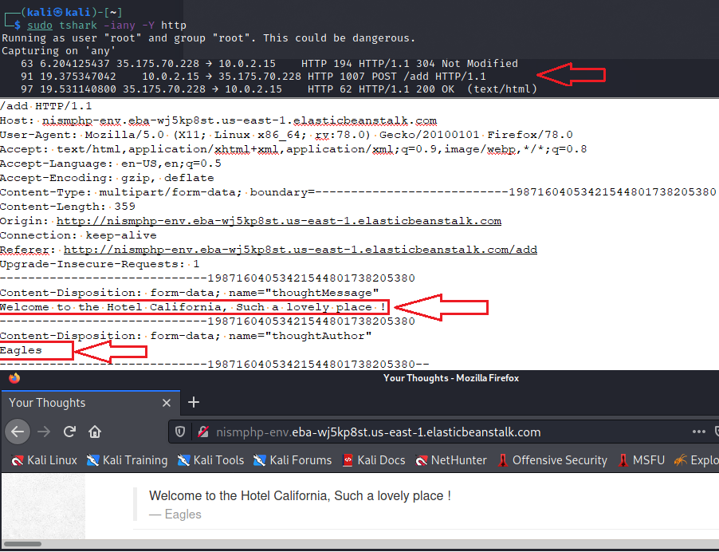

*Figure 9: Human-readable HTTP POST request*

We ran a bash script (Figure 10) with the above understanding to see if the system has any defensive mechanism to avoid flooding and found no security measures like CAPTCHA or timeout to avoid automated flooding.

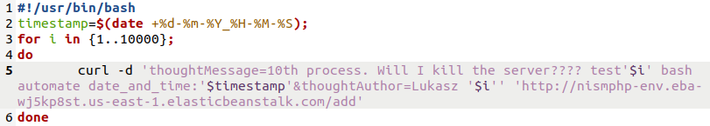

*Figure 10: Bash script*

Subsequently, we switched to scan the available SSH and HTTP server using penetration testing suites like OpenVAS (Figure 11), Nikto (Figure 12), OWASP ZAP (Figure 13) and Metasploit (Figure 14).

OpenVAS and Nikto, provided extensive reports with explanations, matching Common Vulnerabilities and Exposures (CVE) whilst suggesting mitigations. The scan reports also yielded some false positives, which were filtered in the process. OWASP ZAP proved to be instrumental and more efficient than the aforementioned suites. The report had an impressive depth of information. After that, we used Metasploit but were not able to exploit/find any additional SSH vulnerability.

*Figure 11: OpenVAS GUI*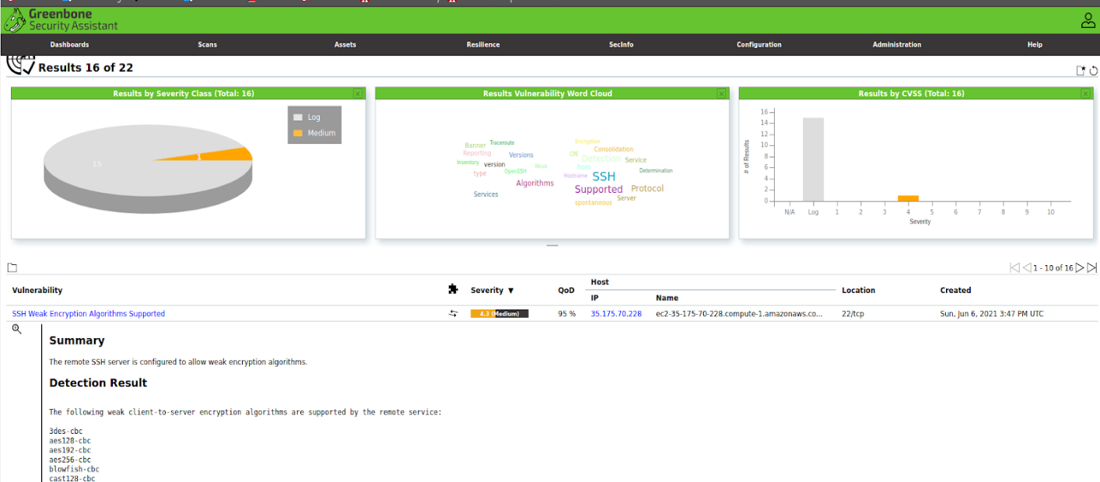

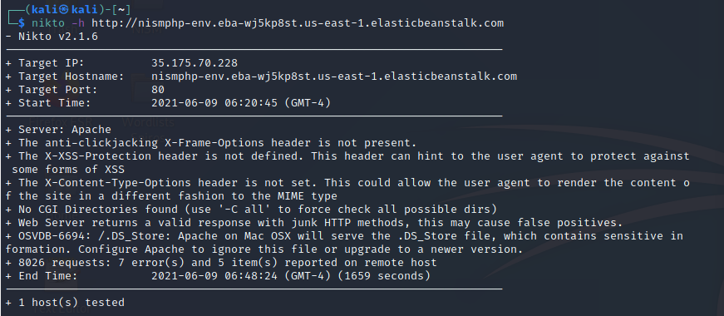

*Figure 12: NIKTO CLI*

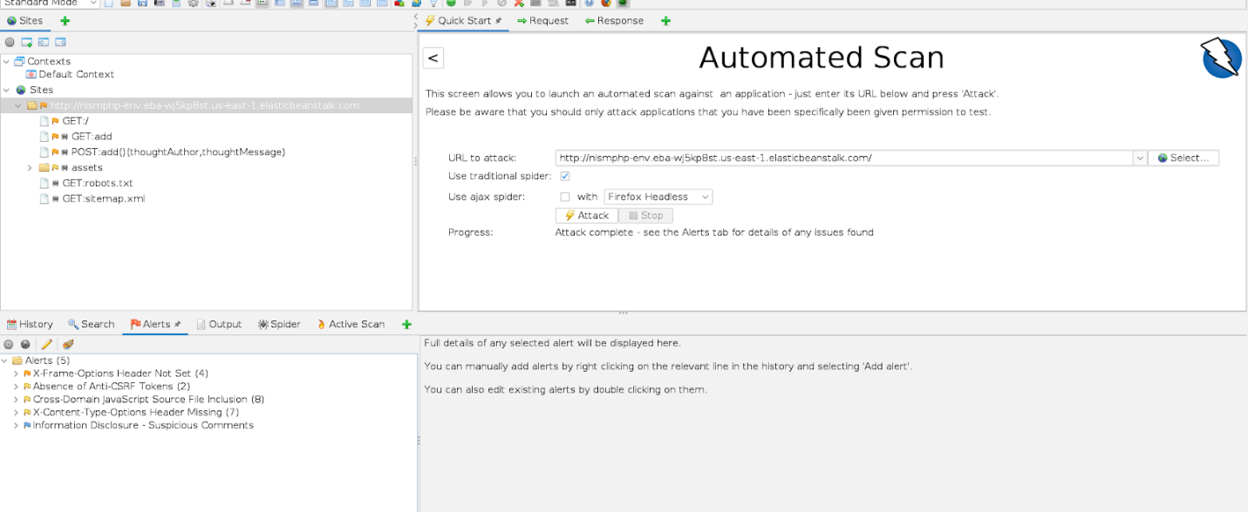

*Figure 13: OWASP ZAP GUI*

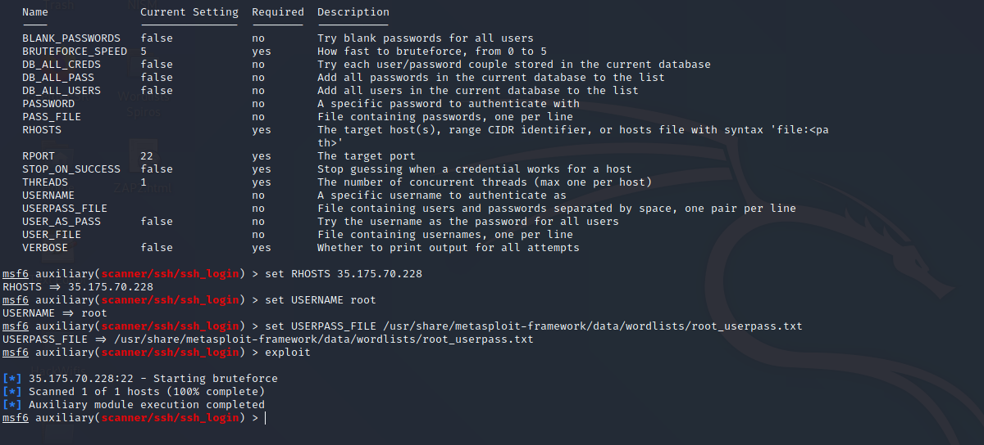

*Figure 14: Metasploit CLI*

**Timeline and Limitations**

With the limited time we had to explore the website, we were still able to coordinate the activities successfully, allowing all the team members to try a plethora of tools using the methodology mentioned above. We concentrated our efforts to perform the scanning independently and then converged to discuss the results/observations. However, we believe that we could have subjected the website to more vulnerability assessment tools with more time.

The web server was hosting a basic PHP web site, with minimal functionality. The scans reported only two processes running SSH and HTTP. As a result, we were not left with many directions to pursue, such as SQL injections, SSL/TLS certificate-based vulnerabilities, to name some. A full-fledged penetration testing could have helped us in validating vulnerabilities. Additionally, access to enterprise assessment tools could have made the scanning process more thorough.

**Conclusion**

The methodology we have used has helped us glean an organised insight while strengthening the understanding of the layered ideology of the TCP/IP thus justifying its popularity in the data networking realm. Kannan et al. (2016) stated that understanding the parts of the network and the relationship between them is essential for a comprehensive network and information security management (NISM) assessment. This focus has allowed us to search for vulnerabilities on each OSI layer (Amos, 2020) and select the appropriate tools for discovering them. Furthermore, the tools and commands that we have used have helped us acquire a good knowledge of penetration testing and NISM assessment fundamentals.

The assessment process was focused on discovering vulnerabilities in the provided server. We intend to expand the assessment with information about e-commerce compliance and standards. Compliance standards serve as vital pillars to address the security and privacy requirements inherent to e-commerce websites.

According to a United Nations Conference on Trade and Development report (UNCTAD, 2020), most governments have legislation about governance and compliance in e-commerce environments. All legislations focus on data protection and privacy and require compliance to GDPR or similar regulations like the California Consumer Privacy Act (CCPA) in the United States. Likewise, the Payment Card Industry Security Standards Council (PCI SSC, N.D.)  has defined standards for creating secure e-commerce products and solutions.

**References**

Amos, J. (2020) 7 Layers of Cybersecurity Threats in the ISO-OSI Model. Available from: https://training.nhlearninggroup.com/blog/7-layers-of-cybersecurity-threats-in-the-iso-osi-model [Accessed 9 June 2021].

Kannan, U., Swamidurai, R., & Umphress, D. (2016) System Dynamics as a Tool for Modeling Application Layer Cyber Security. Available from: https://worldcomp-proceedings.com/proc/p2016/MSV3723.pdf [Accessed 10 June 2021].

PCI Security Standards Council (N.D.) PCI Security Standards Overview. Available from: https://www.pcisecuritystandards.org/pci_security/standards_overview [Accessed 13 June 2021].

Russell, A.L. (2013) OSI: The Internet That Wasn’t - IEEE Spectrum. Available from: https://spectrum.ieee.org/tech-history/cyberspace/osi-the-internet-that-wasnt [Accessed 5 June 2021].

UNCTAD (2020) Summary of Adoption of E-Commerce Legislation Worldwide. Available from:  ‌https://unctad.org/topic/ecommerce-and-digital-economy/ecommerce-law-reform/summary-adoption-e-commerce-legislation-worldwide [Accessed 5 June 2021].

**Bibliography**

Geer, D. (2015) *8 penetration testing tools that will do the job | Network World*. Available from: https://www.networkworld.com/article/2944811/8-penetration-testing-tools-that-will-do-the-job.html [Accessed 14 June 2021].

Greenbone Networks GmbH (N.D.) *OpenVAS - Open Vulnerability Assessment Scanner*. Available from: https://www.openvas.org/#about [Accessed 6 June 2021].

Gordon, L. (N.D.) *Nmap: the Network Mapper - Free Security Scanner*. Available from: https://nmap.org/ [Accessed 8 June 2021].

OWASP Foundation Inc. (N.D.) *OWASP Top Ten Web Application Security Risks*. Available from: https://owasp.org/www-project-top-ten/ [Accessed 7 June 2021].

OWASP Foundation Inc. (N.D.) *OWASP ZAP Zed Attack Proxy | OWASP*. Available from: https://owasp.org/www-project-zap/ [Accessed 10 June 2021].

Rapid7 Inc. (N.D.) *Metasploit | Penetration Testing Software, Pen Testing Security | Metasploit*. Available from: https://www.metasploit.com/ [Accessed 11 June 2021].

Sullo, C. (N.D.) *Nikto2 | CIRT.net*. Available from: https://cirt.net/Nikto2 [Accessed 9 June 2021].

Wireshark Foundation (N.D.) *Wireshark · Go Deep.* . Available from: https://www.wireshark.org/ [Accessed 11 June 2021].